Summary of Benefits and Coverage
: What this Plan Covers & What You Pay for Covered Services Coverage Period: 01/01/2026 - 12/31/2026
Coverage for: Individual + Family | Plan Type: PPO
Thor Industries, Inc.: Plan 63


The Summary of Benefits and Coverage (SBC) document will help you choose a health plan. The SBC shows you how you and the plan would share the cost for covered health care services. NOTE: Information about the cost of this plan (called the premium) will be provided separately. This is only a summary. For more information about your coverage, or to get a copy of the complete terms of coverage, https://eoc.anthem.com/eocdps/aso. For general definitions of common terms, such as allowed amount, balance billing, coinsurance, copayment, deductible, provider, or other underlined terms, see the Glossary. You can view the Glossary at www.healthcare.gov/sbc-glossary/ or call (866) 350-7596 to request a copy.

Important Questions | Answers | Why This Matters:
What is the overall deductible? | $2,500/single or $5,000/family for In-Network Providers. $5,000/single or $10,000/family for Out-of-Network Providers. | Generally, you must pay all of the costs from providers up to the deductible amount before this plan begins to pay. If you have other family members on the plan, each family member must meet their own individual deductible until the total amount of deductible expenses paid by all family members meets the overall family deductible.
Are there services covered before you meet your deductible? | Yes. Primary Care. Specialist Visit. Preventive Care. Children’s eye exam. For more information see below. | This plan covers some items and services even if you haven’t yet met the deductible amount. But a copayment or coinsurance may apply. For example, this plan covers certain preventive services without cost sharing and before you meet your deductible. See a list of covered preventive services at https://www.healthcare.gov/coverage/preventive-care-benefits/.
Are there other deductibles for specific services? | No. | You don't have to meet deductibles for specific services.
What is the out-of-pocket limit for this plan? | $5,000/single or $10,000/family for In-Network Providers. $10,000/single or $20,000/family for Out-of-Network Providers. | The out-of-pocket limit is the most you could pay in a year for covered services. If you have other family members in this plan, they have to meet their own out-of-pocket limits until the overall family out-of-pocket limit has been met.
What is not included in the out-of-pocket limit? | Premiums, balance-billing charges, and health care this plan doesn't cover, and Out-of-Network Transplants. | Even though you pay these expenses, they don’t count toward the out-of-pocket limit.
Will you pay less if you use a network provider? | Yes. BlueCard PPO. See www.anthem.com or call (866) 350-7596 for a list of network providers. Benefits and costs may vary by site of service and how the provider bills. | This plan uses a provider network. You will pay less if you use a provider in the plan’s network. You will pay the most if you use an Out-of-Network provider, and you might receive a bill from a provider for the difference between the provider’s charge and what your plan pays (balance billing). Be aware, your network provider might use an Out-of-Network Provider for some services (such as lab work). Check with your provider before you get services.
Do you need a referral to see a specialist? | No. | You can see the specialist you choose without a referral.

 | All copayment and coinsurance costs shown in this chart are after your deductible has been met, if a deductible applies.

Common  Medical Event | Services You May Need | What You Will Pay |  |  | Limitations, Exceptions, & Other Important Information
Common  Medical Event | Services You May Need | In-Network Provider  (You will pay the least) | Out-of-Network Provider  (You will pay the most) |  | Limitations, Exceptions, & Other Important Information
If you visit a health care provider’s office or clinic | Primary care visit to treat an injury or illness | $40/visit deductible does not apply |  | 40% coinsurance | Virtual visits (Telehealth) benefits available.
If you visit a health care provider’s office or clinic | Specialist visit | $60/visit deductible does not apply |  | 40% coinsurance | Virtual visits (Telehealth) benefits available.
If you visit a health care provider’s office or clinic | Preventive care/screening/  immunization | No charge |  | 40% coinsurance | You may have to pay for services that aren't preventive. Ask your provider if the services needed are preventive. Then check what your plan will pay for.
If you have a test | Diagnostic test (x-ray, blood work) | Lab – Office  No charge  X-Ray – Office  20% coinsurance |  | Lab – Office  No charge  X-Ray – Office  40% coinsurance | --------none--------
If you have a test | Imaging (CT/PET scans, MRIs) | 20% coinsurance |  | 40% coinsurance | --------none--------
If you need drugs to treat your illness or condition  More information about prescription drug coverage is available at www.optumrx.com or call 1-866-735-5654. | Typically Generic (Tier 1) | $15 30-day supply  $30 90-day supply |  | Not covered | -Deductible & Out of Pocket limits do not apply.  Visit www.optumrx.com to locate your pharmacy to fill up to a 30- or 90-days of your medication.  -If you choose Optum Rx Mail Service for your maintenance prescriptions register online at www.optumrx.com or call 1-866-735-5654.
 | Typically Preferred Brand & Non-Preferred Generic Drugs (Tier 2) | $45 30-day supply  $90 90-day supply |  | Not covered
 | Typically Non-Preferred Brand and Generic drugs (Tier 3) | $75 30-day supply  $150 90-day supply |  | Not covered
 | Typically Preferred Specialty (brand and generic) (Tier 4) | 25% with a maximum of $150 |  | Not covered | Optum Specialty Pharmacy must be used to fill 30-day Specialty Medications. Rregister at specialty.optumrx.com/new-fill or call 1-877-656-9604
If you have outpatient surgery | Facility fee (e.g., ambulatory surgery center) | 20% coinsurance |  | 40% coinsurance | --------none--------
If you have outpatient surgery | Physician/surgeon fees | 20% coinsurance |  | 40% coinsurance | --------none--------
If you need immediate medical attention | Emergency room care | $250/visit deductible does not apply |  | Covered as In-Network | Copayment waived if admitted.
If you need immediate medical attention | Emergency medical transportation | 0% coinsurance |  | Covered as In-Network | --------none--------
If you need immediate medical attention | Urgent care | $50/visit deductible does not apply |  | $50/visit, deductible does not apply | --------none--------
If you have a hospital stay | Facility fee (e.g., hospital room) | 20% coinsurance |  | 40% coinsurance | 60 visits/benefit period for Inpatient rehabilitation.
If you have a hospital stay | Physician/surgeon fees | 20% coinsurance |  | 40% coinsurance | --------none--------
If you need mental health, behavioral health, or substance abuse services | Outpatient services | Office Visit  $40/visit deductible does not apply  Other Outpatient  $40/visit deductible does not apply |  | Office Visit  40% coinsurance  Other Outpatient  40% coinsurance | Office Visit  Virtual visits (Telehealth) benefits available.  Other Outpatient  --------none--------
 | Inpatient services | 20% coinsurance |  | 40% coinsurance | --------none--------
If you are pregnant | Office visits | $40/visit deductible does not apply |  | 40% coinsurance | Maternity care may include tests and services described elsewhere in the SBC (i.e., ultrasound).
If you are pregnant | Childbirth/delivery professional services | 20% coinsurance |  | 40% coinsurance
If you are pregnant | Childbirth/delivery facility services | 20% coinsurance |  | 40% coinsurance
If you need help recovering or have other special health needs | Home health care | 20% coinsurance |  | 40% coinsurance | 100 visits/benefit period for Home Health and Private Duty Nursing combined.
 | Rehabilitation services | $60/visit deductible does not apply |  | 40% coinsurance | *See Therapy Services section.
 | Habilitation services | $60/visit deductible does not apply |  | 40% coinsurance | *See Therapy Services section.
 | Skilled nursing care | 20% coinsurance |  | 40% coinsurance | 100 visits/benefit period for skilled nursing services.
 | Durable medical equipment | 20% coinsurance |  | 20% coinsurance | *See Durable Medical Equipment section.
 | Hospice services | No charge |  | No charge | --------none--------
If your child needs dental or eye care | Children’s eye exam | $40/visit deductible does not apply |  | 40% coinsurance | *See Vision Services section.
If your child needs dental or eye care | Children’s glasses | Not covered |  | Not covered | *See Vision Services section.
If your child needs dental or eye care | Children’s dental check-up | Not covered |  | Not covered | --------none--------

Excluded Services & Other Covered Services:
Services Your Plan Generally Does NOT Cover (Check your policy or plan document for more information and a list of any other excluded services.)
- Children’s dental check-up  - Glasses for a child  - Long-term care  - Typically Non-Preferred Brand and Generic drugs (Tier 3)  - Weight loss programs | - Cosmetic surgery  - Hearing Aids  - Routine foot care unless you have been diagnosed with diabetes  - Typically Preferred Brand & Non-Preferred Generic Drugs (Tier 2) | - Dental care (Adult)  - Infertility treatment  - Typically Generic (Tier 1)  - Typically Preferred Specialty (brand and generic) (Tier 4)

Other Covered Services (Limitations may apply to these services. This isn’t a complete list. Please see your plan document.)
- Acupuncture  - Most coverage provided outside the United States. See www.bcbsglobalcore.com | - Bariatric surgery  - Private-duty nursing 100 visits/benefit period combined with Home Health | - Chiropractic care 25 visits/benefit period  - Routine eye care (Adult)

Your Rights to Continue Coverage
: There are agencies that can help if you want to continue your coverage after it ends. The contact information for those agencies is: Ohio Department of Insurance, 50 W. Town Street, Third Floor - Suite 300, Columbus, Ohio 43215, (800) 686-1526, (614) 644-2673, Department of Labor, Employee Benefits Security Administration, (866) 444-EBSA (3272), www.dol.gov/ebsa/healthreform, or contact Anthem at the number on the back of your ID card. Other coverage options may be available to you, too, including buying individual insurance coverage through the Health Insurance Marketplace. For more information about the Marketplace, visit www.HealthCare.gov or call 1-800-318-2596.

Your Grievance and Appeals Rights
: There are agencies that can help if you have a complaint against your plan for a denial of a claim. This complaint is called a grievance or appeal. For more information about your rights, look at the explanation of benefits you will receive for that medical claim. Your plan documents also provide complete information on how to submit a claim, appeal, or a grievance for any reason to your plan. For more information about your rights, this notice, or assistance, contact:
ATTN: Grievances and Appeals, P.O. Box 105568, Atlanta GA 30348-5568
Department of Labor, Employee Benefits Security Administration, (866) 444-EBSA (3272), www.dol.gov/ebsa/healthreform

Does this plan provide Minimum Essential Coverage?
Yes.
Minimum Essential Coverage generally includes plans, health insurance available through the Marketplace or other individual market policies, Medicare, Medicaid, CHIP, TRICARE, and certain other coverage. If you are eligible for certain types of Minimum Essential Coverage, you may not be eligible for the premium tax credit.

Does this plan meet the Minimum Value Standards?
Yes.
If your plan doesn’t meet the Minimum Value Standards, you may be eligible for a premium tax credit to help you pay for a plan through the Marketplace.

To see examples of how this plan might cover costs for a sample medical situation, see the next section.

About these Coverage Examples:
This is not a cost estimator. Treatments shown are just examples of how this plan might cover medical care. Your actual costs will be different depending on the actual care you receive, the prices your providers charge, and many other factors. Focus on the cost-sharing amounts (deductibles, copayments and coinsurance) and excluded services under the plan. Use this information to compare the portion of costs you might pay under different health plans. Please note these coverage examples are based on self-only coverage.

Peg is Having a Baby
(9 months of in-network pre-natal care and a hospital delivery)

The plan’s overall deductible $2,500
Specialist copayment $60
Hospital (facility) coinsurance 20%
Other coinsurance 0%

This EXAMPLE event includes services
like:
Specialist office visits (prenatal care)
Childbirth/Delivery Professional Services
Childbirth/Delivery Facility Services
Diagnostic tests (ultrasounds and blood work)
Specialist visit (anesthesia)

Total Example Cost | $12,700

In this example, Peg would pay:
Cost Sharing
Deductibles | $2,500
Copayments | $50
Coinsurance | $1,300
What isn’t covered
Limits or exclusions | $60
The total Peg would pay is | $3,910
Managing Joe’s Type 2 Diabetes
(a year of routine in-network care of a well-controlled condition)

The plan’s overall deductible $2,500
Specialist copayment $60
Hospital (facility) coinsurance 20%
Other coinsurance 0%

This EXAMPLE event includes services
like:
Primary care physician office visits (including disease education)
Diagnostic tests (blood work)
Prescription drugs
Durable medical equipment (glucose meter)

Total Example Cost | $5,600

In this example, Joe would pay:
Cost Sharing
Deductibles | $0
Copayments | $400
Coinsurance | $0
What isn’t covered
Limits or exclusions | $4,300
The total Joe would pay is | $4,700
Mia’s Simple Fracture
(in-network emergency room visit and follow
up care)

The plan’s overall deductible $2,500
Specialist copayment $60
Hospital (facility) coinsurance 20%
Other coinsurance 0%

This EXAMPLE event includes services
like:
Emergency room care (including medical supplies)
Diagnostic test (x-ray)
Durable medical equipment (crutches)
Rehabilitation services (physical therapy)

Total Example Cost | $2,800

In this example, Mia would pay:
Cost Sharing
Deductibles | $1,300
Copayments | $700
Coinsurance | $0
What isn’t covered
Limits or exclusions | $10
The total Mia would pay is | $2,010

We’re here for you – in many languages
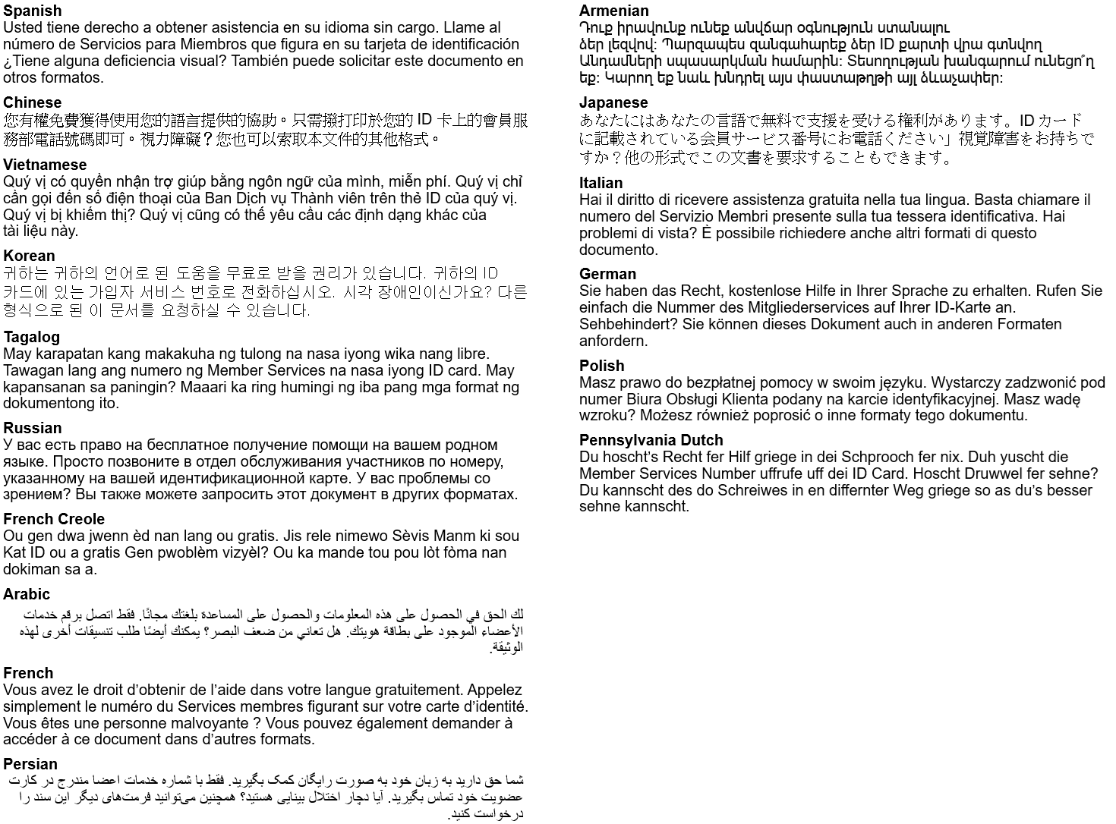
The law requires us to include a message in all of these different languages. Curious what they say? Here’s the English version: “You have the right to get help in your language for free. Just call the Member Services number on your ID card.” Visually impaired? You can also ask for other formats of this document

TTY/TTD:711

It’s important we treat you fairly
We follow federal civil rights laws in our health programs and activities. Members can get reasonable modifications as well as free auxiliary aids and services if you have a disability. We don’t discriminate, on the basis of race, color, national origin, sex, age or disability. For people whose primary language isn’t English (or have limited proficiency), we offer free language assistance services like interpreters and other written languages. Interested in these services? Call the Member Services number on your ID card for help (TTY/TDD: 711) or visit our website. If you think we failed in any areas or to learn more about grievance procedures, you can mail a complaint to: Compliance Coordinator, P.O. Box 27401, Richmond, VA 23279, or directly to the U.S. Department of Health and Human Services, Office for Civil Rights at 200 Independence Avenue, SW; Room 509F, HHH Building; Washington, D.C. 20201. You can also call 1-800- 368-1019 (TDD: 1-800-537-7697) or visit https://ocrportal.hhs.gov/ocr/portal/lobby.jsf

